ECG-Based Arrhythmia Classification with Principal Component Analysis and Machine Learning
Huu Cam Nguyen, Hai-Long Nguyen, Hai-Chau Le, and Nhat Thang Le
Posts and Telecommunications Institute of Technology, Hanoi, Vietnam

Abstract: Cardiovascular diseases (CVDs) remain a leading cause of global mortality, particularly in developing regions where access to advanced diagnostic infrastructure is limited. Electrocardiograms (ECGs), especially 12-lead recordings, play a critical role in detecting cardiac arrhythmias. However, the high dimensionality of ECG data poses computational challenges for real-time and resource-efficient analysis. In this study, we investigate the effectiveness of a Principal Component Analysis (PCA)-based feature selection approach for multi-class arrhythmia classification using 12-lead ECG signals. Four typical arrhythmia categories are analyzed: Atrial Fibrillation (AFIB), Sinus Bradycardia (SB), Sinus Rhythm (SR), and Supraventricular Tachycardia (GSVT). PCA is utilized to identify and retain the most informative features, significantly reducing data dimensionality and enhancing computational efficiency for real-world applications. However, this reduction inevitably introduces a performance offset in classification accuracy. Using the Chapman University ECG dataset of over 10,000 annotated recordings, we evaluated seven widely recognized machine learning models: AdaBoost, Decision Tree, k-Nearest Neighbors, Logistic Regression, Random Forest, Support Vector Machine, and XGBoost. The experimental results indicate that PCA effectively preserves essential ECG signal characteristics despite feature reduction, maintaining robust classification performance, i.e. a remarkable efficiency gains through dimensionality reduction from 212 to 56-81 features while achieving classification accuracies exceeding 97%. The obtained results confirm the potential of PCA-enhanced machine learning as a scalable and accurate solution for automated arrhythmia detection in clinical and mobile health applications.
Keywords: Machine learning, Principal Component Analysis, Feature selection, Electrocardiogram, Arrhythmia Classification.

Introduction
Within the rapid development of digital healthcare, cardiovascular diseases (CVDs) have garnered significant attention due to their persistently high morbidity and mortality rates worldwide. Despite substantial advancements in diagnostic and therapeutic technologies, the burden of cardiovascular diseases remains alarmingly high. The American Heart Association estimates that approximately 45% of the US population will suffer from cardiovascular diseases by 2035, with associated healthcare costs projected to approach $1 trillion [1]. According to the World Health Organization (WHO), CVDs accounted for about 32% of all global deaths in 2019, totaling over 17.9 million fatalities [2]. The situation is particularly critical in developing countries, where limited healthcare infrastructure, scarce medical resources, and insufficient awareness of cardiovascular risk factors exacerbate challenges in effective disease management and intervention [3]. Early detection and timely intervention often lag due to resource constraints and shortages of specialized medical professionals [4][5].
Machine learning (ML) techniques have emerged as a promising solution to address these challenges, demonstrating significant potential in supporting cardiovascular diagnosis and management. Beyond cardiovascular applications, ML has successfully contributed to biomedical fields, including brain anomaly detection, biomedical signal analysis, and clinical decision support systems. In cardiology specifically, ML has facilitated rapid and accurate identification of cardiac abnormalities, thereby contributing to improved patient outcomes and reduced mortality rates [6].
One of the most critical applications of ML in cardiology involves analyzing electrocardiograms (ECGs), which are non-invasive recordings of the heart’s electrical activity acquired via electrodes placed on the skin. ECGs are instrumental in diagnosing various cardiac conditions, including arrhythmias, myocardial infarction, heart failure, and electrolyte imbalances, providing clinicians with swift and reliable diagnostic insights [6][7].
Among existing ECG systems, the 12-lead ECG is considered the gold standard for cardiovascular diagnosis. Compared to fewer-lead systems, such as 1-lead or 3-lead setups, the 12-lead ECG offers a comprehensive perspective on cardiac electrical activity from multiple angles, enabling ML algorithms to extract more detailed and diagnostically relevant features. Consequently, this results in enhanced diagnostic accuracy, particularly for complex arrhythmias and acute cardiac events [8]. Traditionally, ECG-based diagnoses are often corroborated by additional tests, including echocardiography and coronary angiography. However, recent studies have demonstrated that ML models can reliably diagnose cardiac conditions solely using 12-lead ECG data, thereby streamlining diagnostic processes and reducing the necessity for supplementary testing [8][9].
Despite these advancements, several practical challenges persist in applying ML to ECG analysis, including signal noise, inter-patient variability, and the scarcity of accurately annotated datasets [10]. Previous research utilizing extensive datasets, such as the Chapman dataset (containing over 10,000 annotated 12-lead ECG recordings), highlighted that although ML models achieve high accuracy, the extensive data dimensionality introduces computational inefficiencies and processing delays. High-dimensional ECG data frequently includes redundant or noisy information, complicating real-time and resource-constrained analyses.
To address these computational limitations, we investigate the impact of utilizing Principal Component Analysis (PCA) for feature selection of multi-class arrhythmia classification based on 12-lead ECG signals. PCA effectively identifies and retains the most informative ECG signal features, reducing data complexity with a slight diagnostic performance offset, in terms of accuracy. Experimental evaluations demonstrate that applying PCA significantly accelerates data processing, decreases computational overhead, and maintains high diagnostic performance. By enhancing ML models' efficiency and accuracy, our research aims to facilitate their integration into automated diagnostic systems and smart medical devices, ultimately contributing to early, efficient, and reliable cardiovascular disease detection.

Data and Preprocessing
The dataset used in this study was provided by Chapman University in collaboration with Shaoxing People's Hospital and Ningbo First Hospital [11]. Recognized as one of the most comprehensive ECG databases available, this dataset has been extensively utilized in arrhythmia research, underpinning numerous international studies due to its scale and quality. The dataset comprises 12-lead ECG recordings, each spanning a duration of 10 seconds, collected from 10,646 patients. Data were acquired at a sampling frequency of 500 Hz and annotated meticulously by experienced clinicians, covering a range of 11 common cardiac rhythms and an additional 67 cardiovascular conditions. Each ECG record in the dataset is systematically labeled with detailed heart rhythm annotations.
Prior to the application of PCA for feature selection and dimensionality reduction, ECG signals underwent thorough preprocessing using NeuroKit2—a comprehensive Python toolkit designed specifically for extracting physiological features from bio-signals [12][13]. From each ECG lead, 212 significant features were extracted, encompassing heart rate variability parameters, statistical descriptors of ECG waveforms, amplitude measures of ECG waves (P, QRS, T waves), and cardiac cycle phase ratios. Given that the Chapman dataset had already been preprocessed and validated for signal quality, further denoising steps were not necessary.
To streamline classification and enhance clinical relevance, rhythm annotations were grouped by cardiologists into four major arrhythmia categories: Atrial Fibrillation and Flutter (AFIB), Sinus Bradycardia (SB), Sinus Rhythm (SR), and General Supraventricular Tachycardia (GSVT) [14]. This categorization simplified subsequent machine learning tasks, facilitating clearer interpretation of results.
Following initial feature extraction, PCA was implemented to significantly reduce data dimensionality, preserving only the most informative components. PCA was selected due to its proven effectiveness in reducing redundancy and noise while maintaining the integrity and interpretability of physiological data. To prepare the data for PCA, normalization was performed using MinMaxScaler, scaling all feature values uniformly into the [0, 1] range, ensuring stability and comparability across subsequent computational analyses.
To determine the optimal dimensionality reduction, PCA was executed using a variance-based approach, systematically assessing multiple cumulative explained variance thresholds (90%, 95%, 96%, 98%, and 99%). This method enabled precise control over the retained information, ensuring crucial diagnostic features were preserved. For each variance threshold, the minimum number of principal components required to meet or exceed the specified threshold was identified. The selected PCA-transformed datasets were then utilized in downstream classification tasks to empirically evaluate their impact on model performance. Ultimately, the optimal number of principal components retained was determined based on classification accuracy and cross-validation performance. Through this meticulous preprocessing pipeline, the resulting reduced-dimensionality datasets ensured efficient computational performance without compromising diagnostic accuracy, thus supporting robust and scalable machine learning analyses.
Finally, the dataset underwent stratified random splitting into two subsets: 80% for training and 20% for testing, ensuring balanced representation of all arrhythmia classes in both subsets. This stratified approach was selected to preserve the original class distribution, thereby enhancing the reliability and generalizability of subsequent classification outcomes.

Methodology
Figure 1 describes the workflow of our proposed method. Firstly, as described in Section 2, the data are preprocessed with the use of PCA to reduce the dimensionality. PCA helps us retain only the most significant features by selecting components based on their variance. This not only preserves important information but also reduces the number of features for training. The processed data are then split into training and testing sets. The training set is used as input for seven typical machine learning models, and a 3-fold cross-validation is applied to evaluate their performance during training. Finally, the testing set is used to assess the overall performance of the models.
The detailed implementation of each step is presented in the subsections below.

Feature Selection using PCA
PCA was applied to the normalized dataset to effectively reduce dimensionality. PCA identifies principal components by transforming original correlated variables into a new set of orthogonal variables (principal components), arranged in decreasing order of explained variance [15][16]. PCA performs linear dimensionality reduction using Singular Value Decomposition (SVD) to project data into a lower-dimensional space [17]. Dimensionality reduction is the process of reducing the number of variables under, and it plays a key role in extracting features from raw datasets or simplifying data while preserving its structure [18]. PCA's dimensionality reduction efficacy is attributed to its ability to retain maximal variance, thus preserving crucial physiological information while minimizing redundant or irrelevant features.
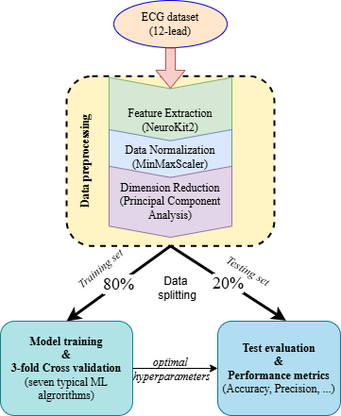
Figure 1. Workflow of 12-lead ECG based arrhythmia classification using PCA
To determine the optimal number of principal components to retain, we applied a variance-based thresholding approach, a widely used method in dimensionality reduction tasks [19-20]. Specifically, we evaluated five cumulative explained variance thresholds from 90% to 100%. For each threshold, we selected the smallest number of components required to reach or exceed the target cumulative variance. This way offers a more flexible and data-driven alternative to the traditional eigenvalue-one criterion, which retains components with eigenvalues greater than 1.0 [20]. In contrast, variance thresholding allows finer control over the amount of information preserved and better adapts to the structure of each dataset. The PCA-transformed datasets corresponding to each threshold were subsequently used for model training and evaluation to assess their impact on classification performance.
In ECG analysis, it is essential to preserve a high proportion of the original variance to ensure that subtle but diagnostically significant features are not lost [19, 20]. Previous studies have shown that selecting too few components can exclude essential physiological patterns, while retaining too many components may introduce redundancy or noise. Conversely, using fewer components (e.g., 90–95%) can reduce training time and the risk of overfitting, especially in smaller or noisier datasets. The number of principal components was determined based on empirical performance observed during cross-validation across the different threshold settings.

Model Training and Validation
Post PCA dimensionality reduction, the transformed data served as input for training seven widely recognized ML classifiers: AdaBoost, Decision Tree, k-Nearest Neighbors, Logistic Regression, Random Forest, Support Vector Machine, and Extreme Gradient Boosting. These classifiers were selected based on their diversity, encompassing various ML paradigms such as ensemble methods, margin-based classifiers, probabilistic models, and instance-based algorithms. Below is a brief description of each model.
- AdaBoost is an ensemble method that combines multiple weak learners into a strong classifier. It works by iteratively adjusting the weights of training instances, placing more focus on those that were misclassified in previous rounds. The final prediction is a weighted vote of all the learners, offering strong performance across various tasks.
- Decision Tree is a rule-based model that splits the dataset into branches based on feature thresholds, forming a tree-like structure. It is easy to interpret but can suffer from overfitting, especially with noisy or complex data.
- k-Nearest Neighbors is a lazy learning algorithm that makes predictions by identifying the k most similar instances in the training set. It classifies a new input based on the majority label among its nearest neighbors, measured by distance in the feature space.
- Logistic Regression is a probabilistic model that maps input features to output probabilities using a sigmoid function. It is suitable for binary classification tasks and assumes a linear relationship between the input variables and the log-odds of the target variable.
- Random Forest is an ensemble of decision trees trained on different subsets of the data and features. This method reduces variance and helps avoid overfitting, making it robust even when working with high-dimensional datasets.
- Support Vector Machine is a margin-based classifier that attempts to find the optimal hyperplane separating different classes. It can model non-linear boundaries by using kernel functions, which makes it effective in complex classification tasks.
- XGBoost is a gradient boosting framework known for its speed and accuracy. It builds decision trees sequentially, where each new tree corrects errors from the previous ones. XGBoost also includes regularization techniques to control overfitting and supports parallel computation for scalability.
A robust 3-fold cross-validation strategy was employed during the training phase, providing a comprehensive evaluation of model performance by systematically partitioning the training set into three subsets. Each model underwent iterative training and validation across these subsets, effectively reducing bias and variance, and ensuring reliable generalization of the models.

Performance Estimation
By analyzing machine learning’s performance metrics, i.e. accuracy, precision, …, together on the testing set, we obtain a comprehensive view of each model's performance following PCA-based feature selection. The evaluation process specifically assessed how well each model performed when applied to previously unseen test data after dimensionality reduction through PCA, with recall and specificity being particularly important in medical diagnosis tasks to minimize the risk of undiagnosed cases and unnecessary treatment, respectively. All metrics were computed using 3-fold cross-validation on the testing dataset to ensure the robustness and generalizability of the PCA-enhanced models.
This detailed evaluation on the test set facilitated precise identification of model strengths and weaknesses in the context of PCA-reduced feature spaces, allowing clear interpretation of performance when PCA preprocessing was applied to unseen data, particularly in the medical diagnostic context. The testing phase evaluation demonstrated how effectively the PCA feature selection strategy translated to real-world performance. This methodological framework integrating PCA-driven feature reduction with systematic testing set evaluation, diverse machine learning models, and comprehensive validation procedures ensured robust, efficient, and clinically meaningful ECG-based arrhythmia classification outcomes that could be reliably assessed on independent test data.

Experimental Results and Discussion

Performance Metrics
To assess the performance of the classification models, key performance indicators including accuracy, precision, recall (sensitivity), F1-score, and specificity are evaluted. Accuracy measures the overall proportion of correctly classified instances, both positive and negative. Precision indicates the proportion of true positive predictions among all predicted positive cases, reflecting the model's reliability when predicting positive results. Recall (Sensitivity) represents the model's ability to correctly identify all actual positive cases (patients with heart disease), which is particularly important in medical contexts where missing a true positive can have severe consequences. F1-score provides the harmonic mean of precision and recall, offering a balanced measure that is especially useful for imbalanced datasets. Specificity measures the model's ability to correctly identify negative cases (patients without heart disease), helping to avoid false alarms. These metrics are calculated as following.
$Accuracy= \frac{TP+TN}{TP+TN+FP+FN}$ (1)
$Precision=\frac{TP}{TP+FP}$ (2)
$Recall= \frac{TP}{TP+FN}$ (3)
$F1-score= 2\left(\frac{\operatorname{Pr}{e}cision.Recall }{\operatorname{Pr}{e}cision+Recall}\right)$ (4)
$Specificity= \frac{TN}{TN+FP}$ (5)
where, True Positive (TP) is the number of patients with heart disease were correctly identified, True Negative (TN) is that of patients without heart disease were correctly identified, False Negative (FN) is the number of patients with heart disease were incorrectly classified as healthy, and False Positive (FP) is the number of healthy patients were incorrectly classified as having heart disease.

In the context of medical diagnosis, false negatives are considered particularly critical, as they may lead to missed diagnoses and delayed treatment. Based on these values, a comprehensive set of performance metrics was calculated to provide a nuanced evaluation of each model's classification capability.
To assess the performance of the classification models, a confusion matrix was constructed for each model to evaluate key performance indicators that are accuracy, precision, recall (sensitivity), F1-score, and Specificity. Confusion matrix provides a clear and comprehensive summary of the model's predictions by categorizing them into four outcomes including True Positive, True Negative, False Positive, and False Negative.
- True Positive (TP): Cases where patients with heart disease were correctly identified.
- True Negative (TN): Cases where patients without heart disease were correctly identified.
- False Negative (FN): Cases where patients with heart disease were incorrectly classified as healthy.
- False Positive (FP): Cases where healthy patients were incorrectly classified as having heart disease.

Performance Evaluation
To evaluate the effectiveness of utilizing PCA in distinguishing different types of arrhythmias from 12-lead ECG signals, we trained and tested seven typical machine learning models independently. Each model, as mentioned in Section II, was tasked with classifying the signals into four categories that are AFIB, SB, SR, and GSVT. The appropriate models were trained using the training dataset and later evaluated on the test set to assess their classification performance.
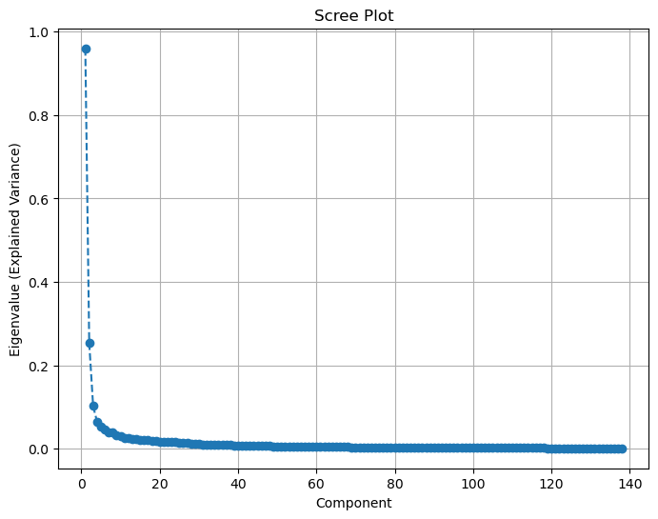
Figure 2. Scree Plot
Before classification, PCA was applied to reduce the dimensionality of the ECG data while retaining the most informative features. As shown in Figure 2, the first few principal components explain a large proportion of the variance, with the first component capturing the majority. After the third component, the explained variance drops off sharply. This suggests that a small number of principal components, particularly the first three, are sufficient to retain most of the essential information from the original dataset.
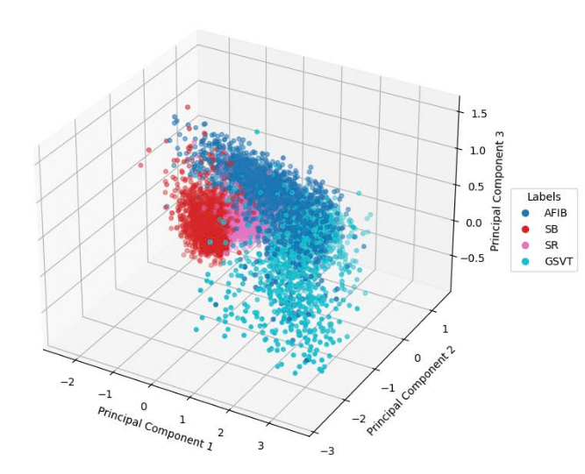
Figure 3. PCA 3D Scatter Plot
Furthermore, Figure 3 provides a 3D scatter plot of the data projected onto the first three principal components. These components were selected based on the scree plot, which showed they capture the most significant variance in the dataset. As shown in the plot, the majority of data points are concentrated in a relatively compact region of the 3D space, indicating that PCA has captured the underlying structure of the ECG signals. The overall distribution demonstrates potential for effective separation of classes using the reduced feature space. There is partial separation between some classes, especially between AFIB (red) and the other rhythm types. Although some overlap exists, particularly among SR, SB, and GSVT, these clusters still exhibit internal consistency, suggesting that class-specific information is retained even after dimensionality reduction.
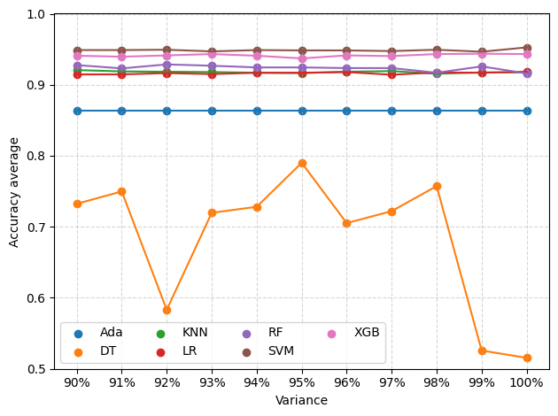
Figure 4. Accuracy comparison for each model with each variance
Figure 4 illustrates the accuracy performance of seven machine learning models that are AdaBoost (Ada), Decision Tree (DT), K-Nearest Neighbors (KNN), Logistic Regression (LR), Random Forest (RF), Support Vector Machine (SVM), and XGBoost (XGB)—evaluated across varying levels of retained variance (90% to 100% (without PCA)) following PCA-based dimensionality reduction for ECG arrhythmia classification. The results demonstrate distinct performance patterns across different variance retention levels. Three models including Random Forest, XGBoost, and SVM exhibit exceptional stability and consistently high accuracy, maintaining performance levels above 0.92 across all variance thresholds, with scores approaching 0.95-0.96 at higher variance retention levels. These ensemble and margin-based methods demonstrate remarkable robustness to dimensionality reduction, suggesting their ability to effectively utilize the most informative features extracted through PCA. In contrast, the Decision Tree model displays significant performance volatility, with accuracy fluctuating dramatically from a low of approximately 0.58 at 99% variance to peaks of 0.82 at 95% variance, indicating potential overfitting issues and sensitivity to feature selection. AdaBoost shows moderate stability with accuracy ranging between 0.85-0.87, while both KNN and Logistic Regression maintain consistent performance around 0.86 and 0.92-0.94 respectively across different variance levels.
TABLE I. Comparison of Classification Model Performance Based on Optimal PCA Values
ML model | Best PCA Value | Accuracy (%) | F1-score (%) | Precision (%) | Recall (%) | Specificity (%) | No. of Features
ADA | 0.91 | 93.2 | 84.6 | 86.4 | 84.8 | 95.3 | 56
DT | 0.95 | 89.5 | 76.4 | 76.4 | 76.2 | 93.1 | 81
KNN | 0.92 | 96.3 | 94.1 | 90.6 | 92.2 | 96.8 | 61
LR | 0.95 | 96.2 | 90.6 | 93.0 | 91.7 | 97.6 | 81
RF | 0.92 | 96.4 | 91.8 | 92.5 | 92.0 | 97.6 | 61
SVM | 0.93 | 97.4 | 94.3 | 94.4 | 94.4 | 98.3 | 61
XGB | 0.93 | 97.2 | 93.6 | 93.9 | 93.7 | 98.1 | 67
Moreover, Table I provides a comprehensive evaluation of each machine learning model's optimal performance following PCA-based feature selection, presenting the best-performing PCA variance retention value for each algorithm along with corresponding performance metrics. The analysis reveals that optimal PCA values range between 0.91 and 0.95, effectively reducing the original 212-dimensional feature space to a more manageable 56-81 features while preserving critical discriminative information for arrhythmia classification.
The results demonstrate exceptional performance across multiple evaluation metrics, with Support Vector Machine achieving the highest overall accuracy of 97.5% at 93% variance retention (67 features), followed closely by XGBoost at 97.2% accuracy with the same variance level. Random Forest and K-Nearest Neighbors also exhibit strong performance, achieving 96.4% and 96.3% accuracy respectively at 92% variance retention, utilizing only 61 features. Notably, these top-performing models maintain balanced performance across all metrics, with F1-scores exceeding 91% and specificity values above 96%, indicating robust classification capability for both positive and negative cases.
TABLE II. Accuracy Comparision
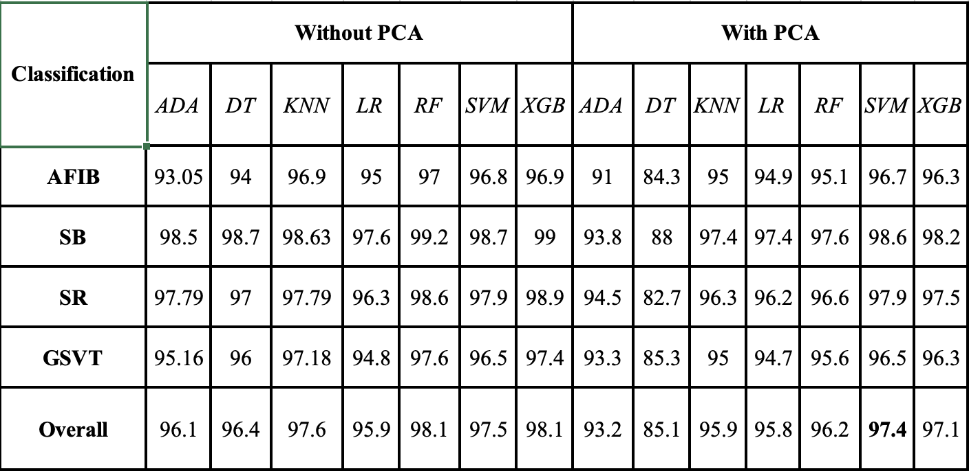
To provide a comprehensive comparative analysis, Table II presents the detailed classification accuracy results for each of the four arrhythmia categories: AFIB, SB, SR, and GSVT, across all seven machine learning models, comparing performance both without PCA preprocessing and with PCA-based feature extraction. The comparative analysis reveals distinct performance patterns between the two approaches. Without PCA, most models demonstrate exceptionally high accuracy across all arrhythmia categories, with Random Forest achieving the highest overall performance at 98.1%, followed by XGBoost (98.1%) and KNN (97.6%). Notably, all models without PCA maintain accuracy levels above 95% for individual arrhythmia classes, with particularly strong performance in detecting Sinus Bradycardia (SB), where most models exceed 98% accuracy.
TABLE III. F1-Score Results For Each Model With Each Variance
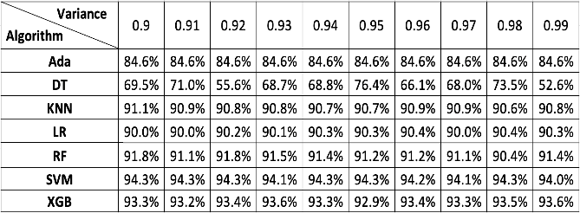
Lastly, Table III summarizes F1-score results with respects to PCA variance for each ML model. It is evident that the application of PCA effectively reduces the dimensionality of the ECG dataset while preserving its essential characteristics. Despite the reduced feature space, the models still maintain high classification performance, which confirms that the most informative components were retained.

Discussion
As illustrated in Figure 4, the maintained high accuracy of top-performing models despite reduced dimensionality (lower variance retention) validates the effectiveness of PCA in preserving the most discriminative features for arrhythmia classification. The superior and stable performance of RF, XGB, and SVM across all variance levels suggests these algorithms are particularly well-suited for ECG-based cardiac abnormality detection, as they can effectively capture complex patterns in the PCA-transformed feature space while maintaining generalization capability.
In addition, Table I implies that the substantial dimensionality reduction achieved, from 212 to approximately 56-81 features (73-79% reduction), while maintaining such high performance metrics validates the effectiveness of PCA in identifying and preserving the most informative features for ECG arrhythmia detection. This reduction not only demonstrates improved computational efficiency and reduced storage requirements but also suggests that the PCA transformation successfully eliminates redundant and noisy features while retaining the essential cardiac signal characteristics necessary for accurate arrhythmia classification. The consistently high specificity values (>93% for all models) are particularly significant in medical applications, as they indicate low false positive rates, thereby minimizing unnecessary patient anxiety and healthcare resource utilization.
Particularly, when PCA preprocessing is applied, the results in Table II show an impressive impact on classification performance. While some models experience slight accuracy reductions, most notably Decision Tree, which drops from 96.4% to 85.1% overall accuracy, other models like SVM and XGBoost maintain robust performance with minimal degradation (97.5% to 97.4% for SVM, 98.1% to 97.1% for XGBoost). The Decision Tree model shows the most significant sensitivity to dimensionality reduction, with substantial accuracy drops across all arrhythmia categories, particularly for AFIB (94% to 84.3%) and SR (97% to 82.7%).
The comparison demonstrates that while PCA achieves substantial feature reduction and computational efficiency gains, the impact on classification accuracy varies significantly across different algorithms. Ensemble methods (RF, XGBoost) and margin-based classifiers (SVM) exhibit greater robustness to PCA preprocessing, maintaining clinically acceptable accuracy levels while benefiting from reduced computational complexity and improved generalization potential.
The F1-score results across different variance retention levels, shown in Table III, reveal distinct performance characteristics among the seven machine learning algorithms for ECG arrhythmia classification. Support Vector Machine demonstrates the most consistent and highest F1-score performance, maintaining approximately 94% across all variance levels from 0.9 to 0.99, indicating exceptional balance between precision and recall regardless of feature dimensionality. XGBoost also exhibits stable performance with F1-scores ranging between 92.9% and 93.6%, demonstrating robust classification capability across different PCA configurations. In contrast, the Decision Tree algorithm shows significant instability with F1-scores fluctuating dramatically from a low of 52.6% at 99% variance to a peak of 76.4% at 95% variance, reflecting its sensitivity to feature selection and potential overfitting issues. Random Forest, K-Nearest Neighbors, and Logistic Regression maintain moderate stability with F1-scores around 91-92%, 90-91%, and 90% respectively, while AdaBoost demonstrates perfect consistency at 84.6% across all variance levels, though at a lower performance tier. The results indicate that SVM and XGBoost are the most reliable algorithms for this classification task, as they maintain high F1-scores while being robust to dimensionality reduction through PCA preprocessing.
These obtained results confirmed that PCA is highly effective for reducing the complexity of ECG datasets without sacrificing classification performance. This has practical implications for real-time or resource-constrained applications, where computational efficiency is essential. By minimizing data redundancy while retaining critical features, PCA helps reduce memory and processing requirements, allowing models to operate faster and more efficiently. Moreover, it can improve model interpretability and generalizability, especially in medical settings where transparency and reliability are crucial.

Conclusion
This study presents a systematic investigation into PCA-based dimensionality reduction for automated arrhythmia classification using 12-lead ECG signals, with the main contribution being the systematic optimization of PCA-based feature selection that achieves up to 73% dimensionality reduction (from 212 to 56-81 features) while maintaining diagnostic accuracy exceeding 97% across multiple machine learning algorithms. Through comprehensive evaluation of seven diverse classifiers, including ensemble methods (Random Forest, XGBoost) and Support Vector Machines, we demonstrated that the proposed approach successfully addresses critical computational challenges in clinical ECG analysis while preserving superior classification performance, achieving F1-scores up to 94.3% and specificity rates exceeding 98%. The systematic analysis of PCA variance thresholds (90%-99%) establishes the 91%-95% range as optimal for balancing dimensionality reduction with information preservation, providing evidence-based guidance for ECG-based arrhythmia detection. These computational efficiency gains enable sophisticated arrhythmia detection in resource-constrained environments and real-time clinical environments.

References
[1] American Heart Association, Cardiovascular Disease: A Costly Burden for America – Projections Through 2035, American Heart Association. Accessed: May 21, 2025. [Online]. Available: https://www.heart.org/-/media/Files/About-Us/Policy-Research/Fact-Sheets/Public-Health-Advocacy-and-Research/CVD-A-Costly-Burden-for-America-Projections-Through-2035.pdf
[2] World Health Organization (WHO), Cardiovascular Diseases (CVDs), WHO. Accessed: May 21, 2025. [Online]. Available: https://www.who.int/news-room/fact-sheets/detail/cardiovascular-diseases-(cvds)
[3] J. Liu, Z. Li, Y. Jin, Y. Liu, C. Liu, L. Zhao, and X. Chen, “A review of arrhythmia detection based on electrocardiogram with artificial intelligence,” Expert Review of Medical Devices, vol. 19, no. 7, pp. 549–560, 2022.
[4] National Institute for Health and Care Research (NIHR), Addressing the Challenge of Cardiovascular Diseases in Low and Middle-Income Countries, NIHR, 2023. [Online]. Available: https://www.nihr.ac.uk/story/addressing-challenge-cardiovascular-diseases-low-and-middle-income-countries
[5] G. A. Roth, G. Nguyen, M. H. Forouzanfar, A. H. Mokdad, M. Naghavi, and C. J. L. Murray, “Early Cardiovascular Disease Mortality Projections for 2025: Global and Regional Estimates,” Circulation, 2023. DOI: 10.1161/CIRCULATIONAHA.123.065717.
[6] Y. Li, Q. Zhang, Z. Wang, W. Wang, and M. Xu, “Application of Machine Learning Algorithms for Predicting the Risk of Cardiovascular Diseases: A Systematic Review,” Frontiers in Cardiovascular Medicine, vol. 8, 749313, 2021.
[7] R. Gupta and S. Sharma, “The Role of Artificial Intelligence in Cardiovascular Disease Prediction: A Comprehensive Review,” Frontiers in Cardiovascular Medicine, vol. 10, 938170, 2023.
[8] P. W. Macfarlane, A. Van Oosterom, O. Pahlm, P. Kligfield, M. Janse, and J. Camm, Comprehensive Electrocardiology, Springer Science & Business Media, 2010.
[9] Y. M. Ayano, F. Schwenker, B. D. Dufera, and T. G. Debelee, “Interpretable Machine Learning Techniques in ECG-Based Heart Disease Classification: A Systematic Review,” Diagnostics, vol. 13, no. 1, p. 111, 2023.
[10] C. T. Chung, S. Lee, E. King, T. Liu, A. A. Armoundas, G. Bazoukis, and G. Tse, “Clinical Significance, Challenges and Limitations in Using Artificial Intelligence for Electrocardiography-Based Diagnosis,” Frontiers in Cardiovascular Medicine, vol. 9, 853830, 2022.
[11] J. Zheng, J. Zhang, S. Danioko, H. Yao, H. Guo, and C. Rakovski, “A 12-lead Electrocardiogram Database for Arrhythmia Research Covering More Than 10,000 Patients,” Scientific Data, vol. 7, no. 1, p. 48, 2020.
[12] Nguyen, H.-L., Pham, V.-S., and Le, H.-C., “Blending Ensemble Learning for Enhanced Arrhythmia Classification Utilizing 12-Lead ECGs,” Computers, vol. 13, no. 16, pp. 316, 2024.
[13] D. Makowski, T. Pham, Z. J. Lau, J. C. Brammer, F. Lespinasse, H. Pham, C. Sch¨olzel, and S. A. Chen, “NeuroKit2: A python toolbox for neurophysiological signal processing,” Behavior Research Methods, vol. 53, no. 4, pp. 1689–1696, feb 2021. [Online]. Available
[14] D. S. Jianwei Zheng, Huimin Chu et al., “Optimal multi stage arrhythmia classification approach,” Scientific reports, vol. 10, no. 1, p. 2898, 2020.
[15] I. T. Jolliffe, and J. Cadima, “Principal component analysis: A review and recent developments”, Philosophical Transactions of the Royal Society A: Mathematical, Physical and Engineering Sciences, vol. 374, no. 2065, pp. 20150202, 2022.
[16] I. T. Jolliffe, “Principal Component Analysis (2nd ed.). Springer Series in Statistics, 2002.
[17] J. Shlens, “A Tutorial on Principal Component Analysis. arXiv preprint, 2014.
[18] P. Domingos, “A few useful things to know about machine learning”, Communications of the ACM, vol. 55, no. 10, pp. 78–87, 2012.
[19] R. J. Martis, U. R. Acharya, and L. C. Min, “ECG beat classification using PCA, LDA, ICA and discrete wavelet transform”, Biomedical Signal Processing and Control, vol. 8, no. 5, pp. 437–448, 2013.
[20] H. Abdi, and L. J. Williams, “Principal component analysis”, Wiley Interdisciplinary Reviews: Computational Statistics, vol. 2, no. 4, pp. 433–459, 2010.

 | Huu Cam Nguyen received the B.E degree from Hanoi University in 2013, and the M.E of Information System Design of University of Central Lancashire, United Kingdom in 2016. He joined the Research Institute of Posts and Telecommunications in Vietnam. He is currently a lecturer in Telecommunications Faculty at PTIT. He is pursuing the PhD degree in the field of information systems. His research interests include Machine Learning, Bioinformatics and Information System Design.

 | Hai-Long Nguyen is currently a research student in Data and Intelligent Systems Laboratory at Posts and Telecommunications Institute of Technology (PTIT), Viet Nam. His research interests include machine learning, bioinformatics, and data science.

 | Hai-Chau Le received the B.E. degree in Electronics and Telecommunications Engineering from Posts and Telecommunications Institute of Technology (PTIT) of Vietnam in 2003, and the M.Eng. and D.Eng. degrees in Electrical Engineering and Computer Science from Nagoya University of Japan in 2009 and 2012, respectively. From 2012 to 2015, he was a researcher in Nagoya University of Japan and in University of California, Davis, USA. He is currently a lecturer in Telecommunications Faculty at PTIT. His research interests include optical technologies, network design and optimization, and future network technologies. He is an IEEE member.

 | Nhat Thang Le received the B.Eng degree in Radio-Electronics and Communication from Hanoi University of Science and Technology (HUST), Vietnam, in 1995, the M.Eng degree in Telecommunications from Asian Institute of Technology (AIT), Bangkok, Thailand, in 2000 and Ph.D. degree in Information and Communication Technology (ICT) from the Department of Computer Science and Telecommunications (DIT), University of Trento, Italy in 2006. He is currently an Assoc. Professor and the Dean of Postgraduate Studies Faculty, Posts and Telecommunications Institute of Technology (PTIT), Hanoi, Vietnam. His research interests now are performance analysis, modeling and simulations, wireless communications systems, physical layer security, queueing theory and applications, machine learning, deep learning, optimization, biomedical applications.

GIẢI PHÁP PHÂN LOẠI LOẠN NHỊP TIM DỰA TRÊN ECG SỬ DỤNG KỸ THUẬT PHÂN TÍCH THÀNH PHẦN CHÍNH VÀ HỌC MÁY

Nguyễn Hữu Cầm, Nguyễn Hải Long, Lê Hải Châu và Lê Nhật Thăng*
Học viện Công nghệ Bưu chính Viễn thông
* Email liên hệ: thangln@ptit.edu.vn

Tóm tắt: Các bệnh tim mạch (CVD) vẫn là một trong những nguyên nhân hàng đầu gây tử vong trên toàn cầu, đặc biệt là ở các khu vực đang phát triển, nơi cơ sở hạ tầng chẩn đoán tiên tiến còn hạn chế. Tín hiệu điện tâm đồ (ECG), đặc biệt là bản ghi 12 chuyển đạo, đóng vai trò quan trọng trong việc phát hiện rối loạn nhịp tim. Tuy nhiên, dữ liệu ECG có số lượng đặc trưng lớn gây ra những thách thức tính toán đối với các ứng dụng thời gian thực và tiết kiệm tài nguyên. Trong nghiên cứu này, chúng tôi khảo sát hiệu quả của phương pháp lựa chọn đặc trưng dựa trên kỹ thuật phân tích thành phần chính (PCA) trong bài toán phân loại đa lớp rối loạn nhịp tim sử dụng tín hiệu ECG 12 chuyển đạo. Bốn loại rối loạn nhịp phổ biến được phân tích gồm: Rung nhĩ (AFIB), Nhịp chậm xoang (SB), Nhịp xoang (SR), và Nhịp nhanh trên thất (GSVT). PCA được sử dụng để xác định và giữ lại các đặc trưng chứa đựng nhiều thông tin nhất, từ đó giảm đáng kể số chiều dữ liệu và tăng hiệu quả tính toán trong các ứng dụng thực tế. Tuy nhiên, việc giảm số chiều này cũng kéo theo một sự đánh đổi nhất định về độ chính xác phân loại. Sử dụng bộ dữ liệu ECG từ Đại học Chapman với hơn 10.000 bản ghi được chú thích, chúng tôi đánh giá bảy mô hình học máy phổ biến: AdaBoost, cây quyết định, K-láng giềng gần nhất, hồi quy logistic, rừng ngẫu nhiên, máy vector hỗ trợ, và XGBoost. Kết quả thực nghiệm cho thấy PCA có khả năng giữ lại những đặc điểm quan trọng của tín hiệu ECG mặc dù số đặc trưng bị giảm, đồng thời vẫn duy trì hiệu suất phân loại ổn định, cụ thể là đạt được mức giảm số chiều từ 212 xuống chỉ còn 56-81 đặc trưng, trong khi độ chính xác phân loại vẫn vượt trên 97%. Những kết quả này khẳng định tiềm năng của học máy kết hợp PCA như một giải pháp chính xác và có khả năng mở rộng cho hệ thống phát hiện rối loạn nhịp tim tự động trong các ứng dụng y tế lâm sàng và sức khỏe di động.
Từ khoá: Học máy, Phân tích thành phần chính, Lựa chọn tính năng, Điện tâm đồ, Phân loại loạn nhịp tim, ...

